Weather App

Contents

1 Preface 1

2 Introduction 1

What is the Weather Forecasting? 1

Specialist Forecasting 2

3 Prerequisites 2

4 Application Architecture 2

5 Python Implementation 3

5.1 Project structure 3

5.2 Code Explanation 4

5.3 Output 6

# Preface

This document is intended towards helping all the data scientists out there. It is a step by step guide for creating a `Weather App`. In this case, a weather application right from scratch and can be deployed in any cloud platform. This document takes a simple example of a weather application process from scratch and shows recent 5 city search of weather.

# Introduction

## What is the Weather Forecasting?

**Weather forecasting** is the application of science and technology [to predict](https://en.wikipedia.org/wiki/Forecasting) the conditions of the [atmosphere](https://en.wikipedia.org/wiki/Earth%27s_atmosphere) for a given location and time. People have attempted to predict the [weather](https://en.wikipedia.org/wiki/Weather) informally for [millennia](https://en.wikipedia.org/wiki/Millennia) and formally since the [19th century](https://en.wikipedia.org/wiki/19th_century). Weather forecasts are made by collecting quantitative [data](https://en.wikipedia.org/wiki/Data) about the current state of the atmosphere at a given place and using [meteorology](https://en.wikipedia.org/wiki/Meteorology) to project how the atmosphere will change.

## Specialist Forecasting

Air traffic

Marine

Agriculture

Forestry

Military

# Prerequisites

The things needed before we start building a python based Weather App are:

* Python installed.
* A Python IDE (Integrated Development Environment): like PyCharm, Spyder, or any other IDE of choice (Installation Process is provided in installation section)
* Django Installed. (A simple command: pip install django)
* Basic understanding of Python and HTML.
* Basic understanding of Git (download Git CLI from https://gitforwindows.org/)

# Application Architecture

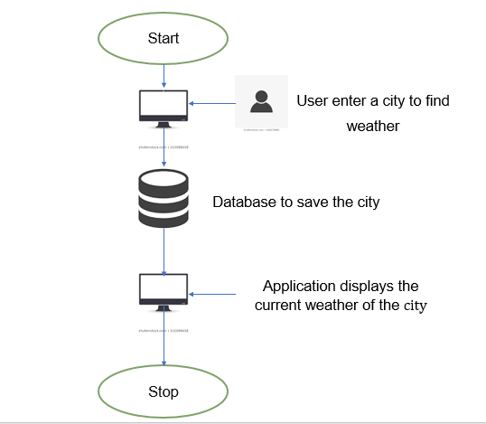

# Python Implementation

## Project structure

Note: VSCode has been used as an IDE for this documentation

1. Let’s create a folder called ‘templates’ on our local machines inside the weather app.
2. Inside that folder, let’s create one more file called ‘index.html’ to hold

the code for the UI of our application.

1. The index.html file will display the information entered by user in tabular format and is going to be updated when user enters a new item.

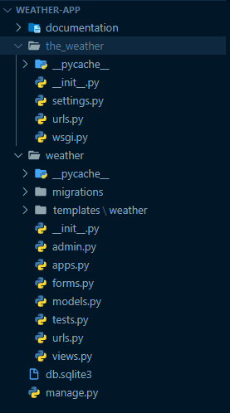

## Code Explanation

1. Import the necessary libraries:

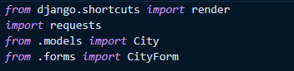

1. Form class to get and store input by user in database.

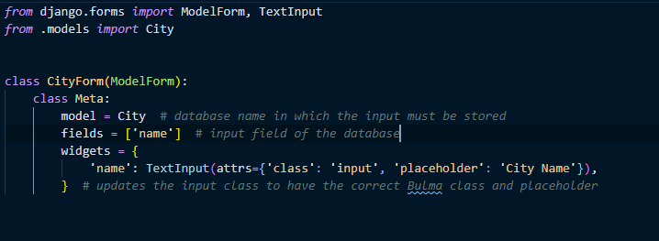

1. Now let’s understand the functions.

* If the HTTP request method is POST, then the city name will be stored in database and user will able to see result in same page.

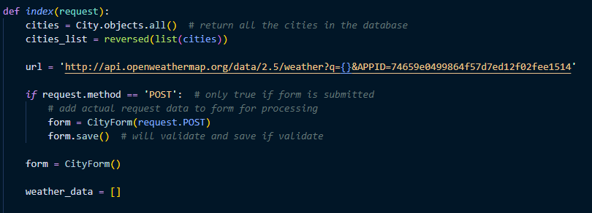

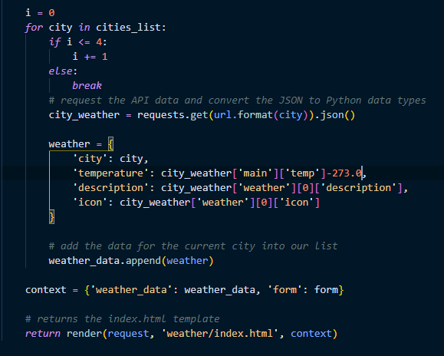

## Output

